Best Raspberry Pi Projects for Beginners
If you're looking for a fun and easy way to get started with Raspberry Pi, then creating a simple project is the way to go. By doing this, you'll be able to get a feel for how the Raspberry Pi works and how to use it to create your own projects.
There are tons of different projects you can create, but for beginners, we recommend starting with something simple like an LED blinker. This project is perfect for those new to the Raspberry Pi, as it only requires a few basic components and is easy to follow. Plus, it's a great way to learn the basics of coding and electronics.In this article we will be looking at the different projects suitable for beginners.

A simple web server.
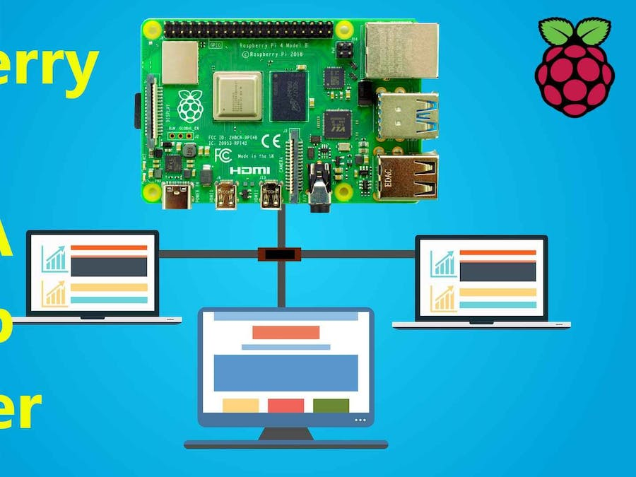
To create a web server using Raspberry Pi, you will need a few hardware components. Firstly, you will need a Raspberry Pi board. You can use any model of Raspberry Pi, but we recommend using the latest model for best performance. Secondly, you will need an SD card. We recommend using a high-speed SD card with at least 8GB of storage. Thirdly, you will need a power supply. We recommend using a 5V power supply with at least 2A of current. Finally, you will need a network connection. We recommend using a wired Ethernet connection for best performance.
There are three software requirements for creating a web server using Raspberry Pi. The first is a web server application, the second is a database management system, and the third is a scripting language.

The web server application is responsible for handling HTTP requests and responses. It is also responsible for serving web pages to clients. There are many different web server applications available, but the most popular ones are Apache and Nginx.

The database management system is responsible for storing and retrieving data. The most popular database management system is MySQL. However, there are many other options available, such as PostgreSQL, MongoDB, and SQLite.

The scripting language is responsible for processing data and generating dynamic content. The most popular scripting languages are PHP and Python. However, there are many other options available, such as Perl, Ruby, and JavaScript.

Testing is a vital part of the software development process. It helps ensure that the software is working as intended and that there are no bugs or errors. There are many different types of tests, but some of the most common are unit tests, integration tests, and regression tests.
Unit tests are used to test individual components or units of code. They are typically written by the developers who wrote the code being tested.

A simple web server is a great way to get started with web development on the Raspberry Pi. To create a web server, you will need to install the Apache web server software and the PHP programming language.

A media center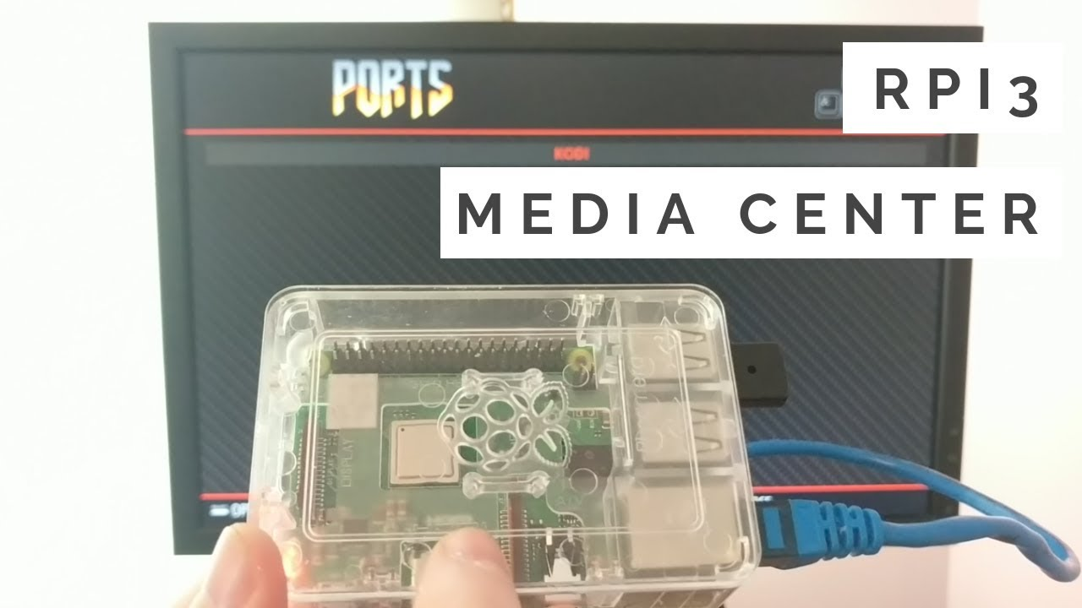

A media center is a great way to have all your movies, music, and TV shows in one place. You can either buy a pre-made media center or build your own. If you build your own, you'll need a Raspberry Pi, a case, a power supply, an SD card, and a TV.
In this kind of project, you can be using a Raspberry Pi 3 Model B, which is the latest version of Raspberry Pi. You will use the Raspbian operating system, which is based on the Debian Wheezy distribution. Raspbian is a free operating system that comes with over 35,000 packages. It is the official operating system for the Raspberry Pi.
there are a few things you need to do. First, you need to install the operating system on your Raspberry Pi. We recommend using the Raspbian operating system. Once you have installed Raspbian, you need to install the Kodi media center software. Kodi is a free and open source media player that is very popular on Raspberry Pi.
Once you have Kodi installed, you can start adding your media files to it. Kodi supports a variety of audio and video formats, so you should have no problem adding your media files to it. You can also add plugins to Kodi to give it additional functionality. For example, you can install the Netflix plugin to watch Netflix on your Raspberry Pi.
Setting up your Raspberry Pi media center is a relatively simple process. Just make sure you have the right hardware and software, and you should be up and running in no time.
Raspberry Pi is a great tool for creating a media center.It is also very inexpensive, which makes it a great option for those on a budget. There are many different operating systems that can be used on a Raspberry Pi, but the most popular one is Raspbian
If you're not sure how to set up a media center, there are plenty of tutorials online. Once you have everything set up, you'll be able to watch your favorite movies, listen to your favorite music, and play your favorite games all in one place.

A home automation system.
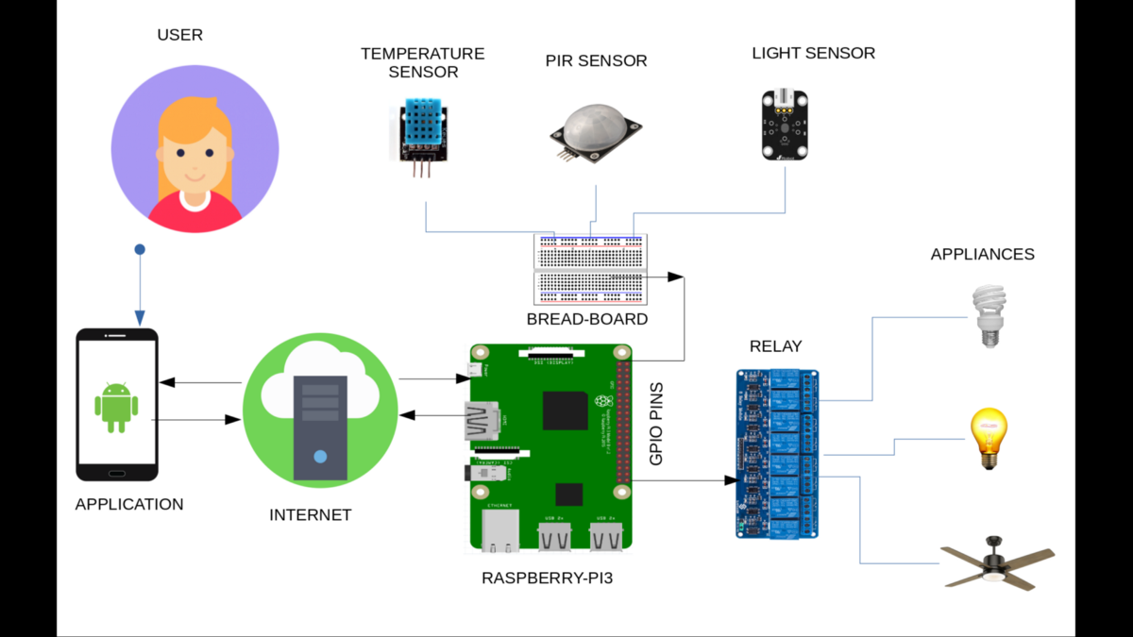
A home automation system is a great way to make your home more comfortable, convenient, and energy efficient. There are many different types of home automation systems on the market, but the best ones share some common features. A good home automation system should be easy to use, support a variety of devices, and be affordable.
The best home automation systems are those that are easy to use. The last thing you want is a system that is difficult to control or that requires a lot of programming. A good home automation system should have a user-friendly interface that makes it easy to control all of your devices.
Another important feature to look for in a home automation system is support for a variety of devices. The best systems will work with a wide range of devices, including thermostats, lighting, security cameras, and more. This way, you can control all of your devices from one central location.
Finally, you should make sure that the home automation system you choose is affordable. There are many high-end systems on the market, but you don’t necessarily need to spend a lot of money to get a good one.

A gaming system.
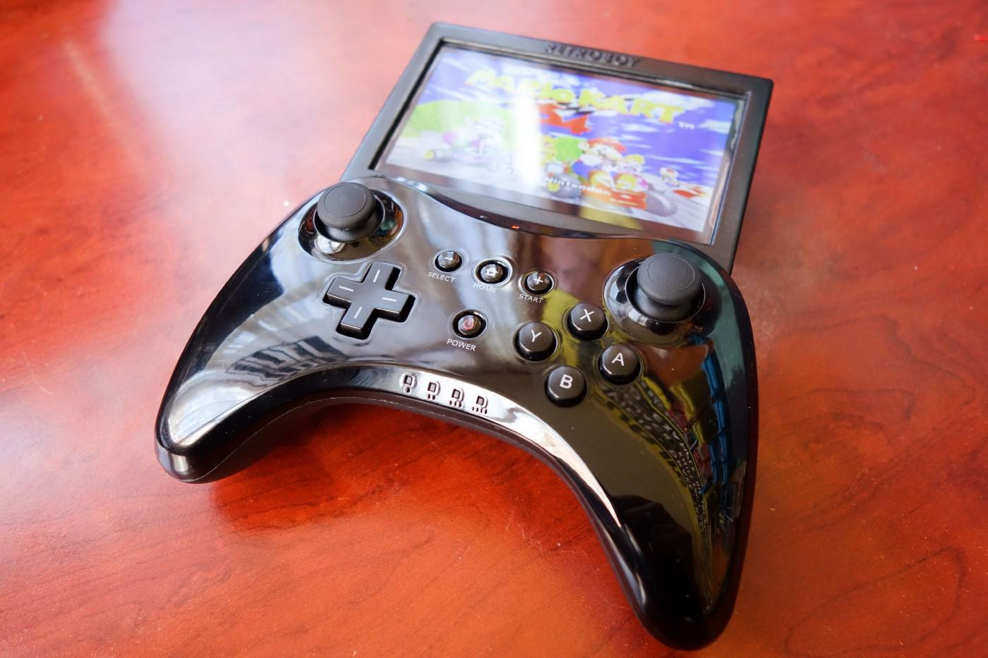

A Raspberry Pi can be a great way to create a gaming system. There are a few benefits to using a Raspberry Pi to create a gaming system. First, the Raspberry Pi is small and can easily be hidden away. Second, the Raspberry Pi is powerful enough to play a wide variety of games. Third, the Raspberry Pi is relatively inexpensive, making it a great option for those on a budget. Finally, the Raspberry Pi can be used to create a wide variety of gaming systems, from simple retro systems to more complex systems that can play modern games

You will need a Raspberry Pi 3 Model B or B+, a microSD card with NOOBS installed, a power supply, and a controller. You will also need a monitor or television to use as your display, and an HDMI cable to connect the Pi to the display.

Once you have all of the hardware, you can begin setting up your system. First, you need to install RetroPie, which is a software package that allows you to turn your Raspberry Pi into a retro gaming console. You can do this by following the instructions on the RetroPie website.

Once RetroPie is installed, you can start adding games to your system. There are a few ways to do this, but the easiest is to simply download ROMs (game files) from the internet and copy them to your microSD card. You can then load them into RetroPie and start playing.

That's all there is to it! With a little bit of effort, you can turn your Raspberry Pi into a fully-functional retro gaming console.
However, there are certain drawbacks of using a Raspberry Pi to create a gaming system.For one, the processing power of a Raspberry Pi is relatively low compared to a dedicated gaming console or even a mid-range smartphone. This can result in sub-par gaming performance, especially if you are trying to play graphically demanding games.
Another issue is that the Raspberry Pi does not have a dedicated GPU, which means that it relies on the CPU for all graphical processing. This can again lead to lower than expected performance, especially in games that are heavy on graphical effects.
Finally, the Raspberry Pi also lacks some of the features that are found on dedicated gaming consoles, such as support for high-resolution graphics, built-in storage, etc. This can make it difficult to get the most out of your games on a Raspberry Pi.

A security system.
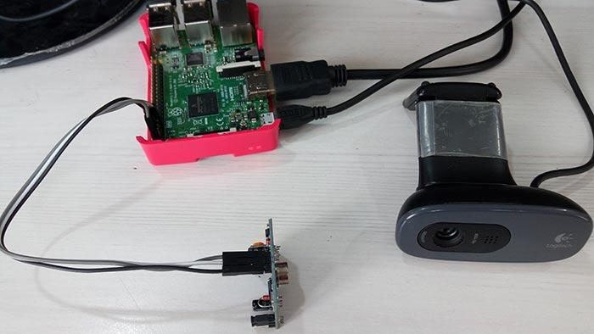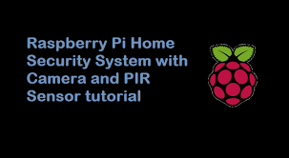
The Raspberry Pi is a great platform for building a home security system because it is:

- Inexpensive - The Raspberry Pi costs around $35, which is much cheaper than a traditional home security system.

- Customizable - You can tailor the Raspberry Pi security system to your specific needs. For example, you can add sensors to detect intruders, or cameras to capture images or video.

- Easy to use - The Raspberry Pi is easy to set up and use. You can install the required software yourself, or use a pre-made image such as the one from the Noobs project.

- Versatile - The Raspberry Pi can be used for other projects besides a security system. For example, you could use it as a home automation controller, or a media center.

A security system using the Raspberry Pi can be created in a number of ways. One way is to use a motion sensor to detect when someone is in the area and then have the Raspberry Pi take a photo or video of the person. The photo or video can then be sent to a security company or the police. Another way to use a Raspberry Pi to create a security system is to use it to monitor the doors and windows of a home or business. If a door or window is opened, the Raspberry Pi can send an alert to the owner or the security company.

There are several challenges associated with using Raspberry Pi for security systems. First, the Raspberry Pi is a very small computer, which means that it has limited processing power and memory. This can make it difficult to run complex security software on the device. Additionally, the Raspberry Pi is designed to be used with various types of input and output devices, which can make it challenging to connect the device to traditional security systems. Finally, the Raspberry Pi is a relatively new platform, which means that there may be few security-related software applications available for the device.

A security system using a Raspberry Pi can be a great way to deter burglars and keep your home or business safe. By using a motion sensor and a camera, you can create a system that will send you alerts when someone is on your property. You can also use the system to record video and take pictures of the intruder.

What are you waiting for?
If you're looking for some great Raspberry Pi projects to get started with, then you've come to the right place. In this article, we have shared some of the best Raspberry Pi projects for beginners. These projects are perfect for those who are just getting started with the Raspberry Pi, or for those who want to learn more about the Raspberry Pi and its capabilities.
Grab your Raspberry Pi and get started on one of these fun projects today.

